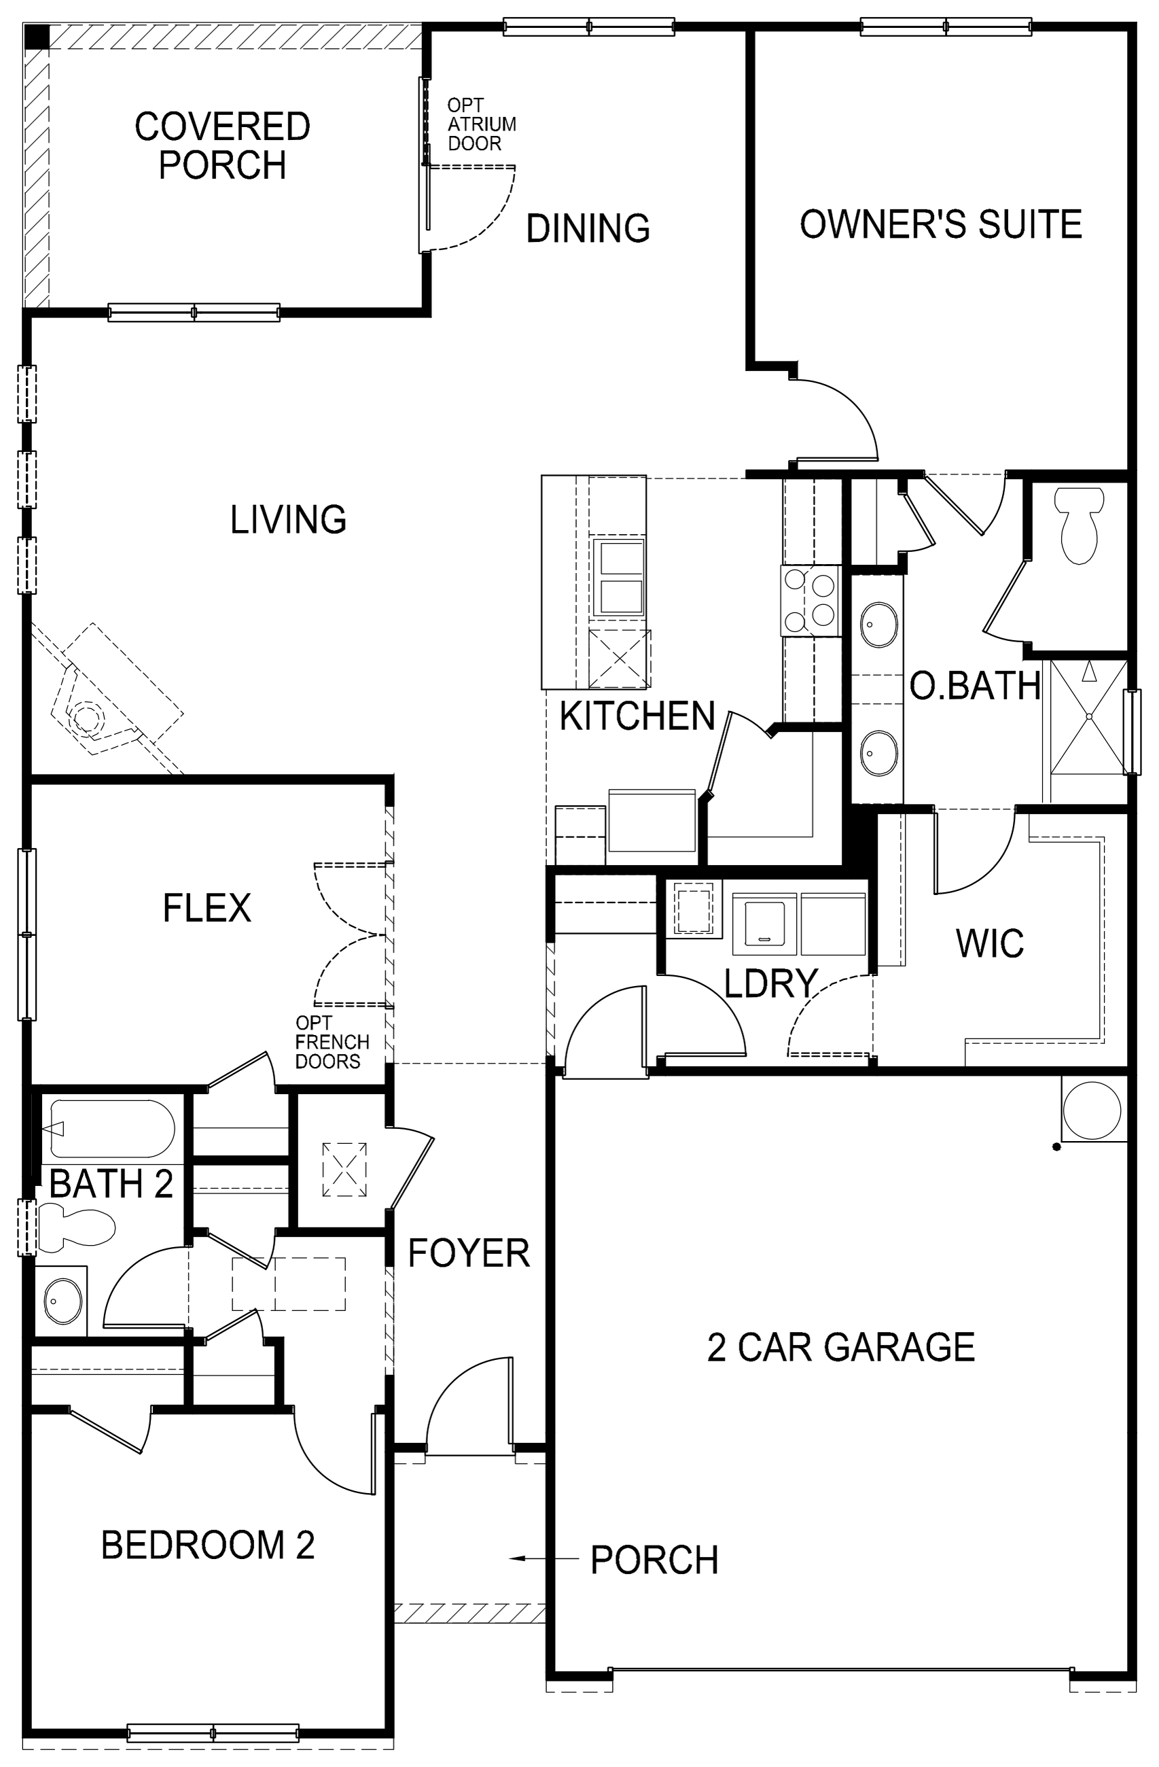
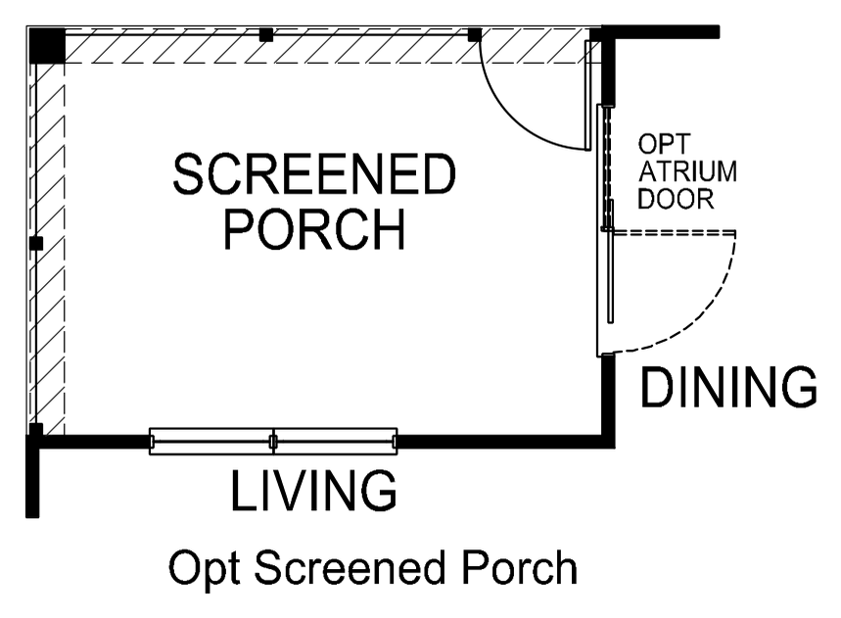
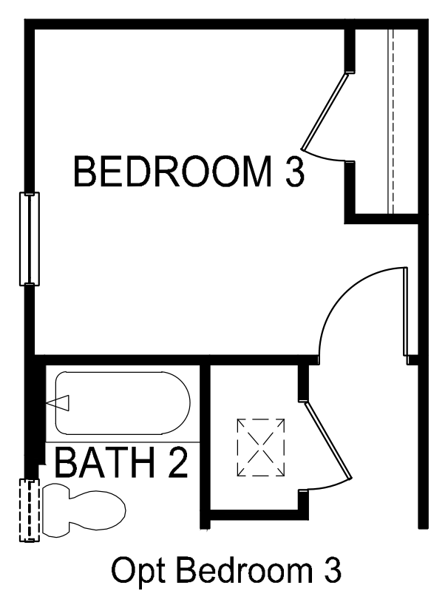
14'-0" x 10'-0"
11'-0" x 15'-8"
13'-1" x 15'-4"
18'-0" x 16'-0"
DW
10'-6" x 13'-8"
PANTRY
SEAT
REF
W
12'-5" x 10'-6"
OPT SINK
D
OPT VALET
OPT
MECH
WH
LINEN COATS
LINEN
20'-1" x 20'-10"
12'-5" x 11'-0"
5'-4" x 6'-0"
14'-0" x 10'-0"
OPT SCREENED PORCH
10'-0" x 10'-6"
MECH
OPT BEDROOM 3
OPT FIREPLACE
OPT 2030 SH
(3) OPT 2020 FX
RANGE
LINEN
OPT 2030 SH

FIRST FLOOR PLAN

